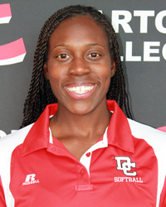

Darton College

Amber Miles

229-317-6235

amber.miles@darton.edu

Former D-1 standout and Louisiana Tech assistant coach, Amber Miles, became head coach of the Lady Cavaliers this fall, and brings years of high-level coaching experience, a masters-degree level of education and an exceptional background as a NCAA D-1 student-athlete to the Darton program.

“Coach Miles emerged as the search committee’s top selection from an excellent pool of candidates,” said Darton State College Athletics Director Mike Kiefer. "I anticipate her coaching philosophies, softball experiences, desire for excellence, and ability to communicate effectively with student athletes will lead to sustained success for the Darton State College softball program.”

Miles held a role as assistant softball coach of Louisiana Tech for five years before taking a position at The University of Texas at Dallas in 2012. There she held a dual role as assistant softball coach and academic advisor until her present hire into the Lady Cavalier program. Much of her duties as an assistant coach centered on working with outfielders and left-handed slappers, recruiting, scheduling and fundraising.

As a student-athlete, Miles was a four-year varsity starter for the Lady Techsters and set a record for most hits in a single season. Regarded as one of the top outfielders in the Western Atlantic Conference, Miles earned all-league honors twice and ended her playing career as one of the top three base-stealers in the program’s history. She also excelled as a student and was a four-time Academic All-WAC selection.

"I would like to thank Athletic Director Mike Kiefer for believing in my vision for this program and providing me with this opportunity," Miles said. "I appreciate the search committee giving me an idea of what wonderful places Albany and Darton State College are. I hold the same philosophy as Darton State College and its athletic department. We all strongly believe in the academic and athletic sides of the student-athlete, and I look forward to continuing this mentality within our program. I am honored to lead a group of student-athletes who already understand hard work and who are committed to putting in the time and effort that it takes to succeed on and off the field.”

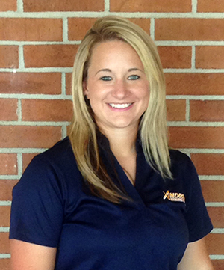

**Andrew College**

**Kayla Williams  
229-732-5937**[**kaylawilliams@andrewcollege.edu**](mailto:kaylawilliams@andrewcollege.edu)

Kayla Williams will begin her third season at Andrew College, and first as Head Softball Coach. She is a 2010 graduate of Emmanuel College, with her B.S. in Early Childhood Development.

Kayla is a 2005 graduate of Jackson County High School in Jefferson, GA, where she was a four-year letter winner in softball, basketball, and golf. She earned first team all-region honors for softball and helped lead her team to their first ever Elite Eight appearance in 2001. After high school, she signed a softball scholarship with Emmanuel College, located in Franklin Springs, GA. During her junior season at Emmanuel College she earned an all-conference award, as she finished the year hitting with a .342 avg, 14 doubles, 5 homeruns, and 22 RBI for the year, leading her team to an overall record of 32 wins and 22 losses. She was very versatile in her collegiate career, coming to Emmanuel College as a middle infielder, but taking advantage of her speed, was moved to the outfield predominantly, while also seeing time at second base and shortstop. She was a four year starter for the Lady Lions.

Kayla is entering her fifth year of coaching. She spent two years at Deerfield-Windsor High School located in Albany, GA, as an assistant, before becoming the Head Assistant Coach at Andrew College for the past two seasons. She also coached one summer with a travel softball team based out of northeast GA.

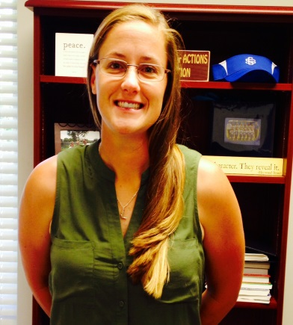

Nicki Levering

|  |  |
| --- | --- |
| 912.260.4222 | [nichole.levering](mailto:nichole.levering@sgsc.edu)@sgsc.edu |

South Georgia State College

Head Softball Coach

Former White House, Tennessee native Levering comes to SGSC with a great deal of playing and coaching experience. She played catcher and third base at both Seminole Community College (Sanford, Florida) and Trevecca Nazarene University (Nashville, Tennessee), where she was a NFCA Academic All-American (2005, Seminole Community College) and team captain (TNU, 2008). At TNU, she earned a Bachelor in Exercise Science along with winning the NAIA Regional IX championship and the NAIA Tran South Conference Championship in 2007 and 2008.After her playing career ended, she served as a graduate assistant for two years at the University of North Alabama receiving her Master’s Degree in Health and Human Performance before moving to Galveston College. While an Assistant at Galveston, her team won the NJCAA Region 14 tournament and finished seventh in the country in 2013. Over the previous three years, 14 players at Galveston graduated as NJCAA Academic All-Americans, and produced two All-American NJCAA Division 1 athletes; one NJCAA Region 13 MVP; eight NJCAA Division 1 All-Conference First-Team athletes, and five Division 1 All-Conference Second-Team athletes.

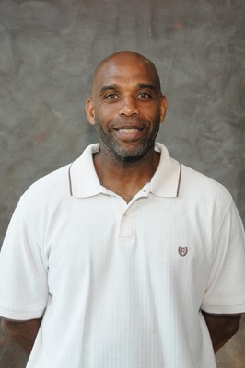   
Albany State

**Robert G. Skinner**  
Head Women's Basketball, Volleyball & Softball Coach  
  
Phone: 229-430-3817  
Email:  [robert.skinner@asurams.edu](mailto:robert.skinner@asurams.edu)  
  
In his 21st season as head coach of the Albany State University Lady Rams, Robert Skinner has built one of the most successful college women's basketball teams in the Southern Intercollegiate Athletic Conference (SIAC) and the South Region  
  
Known for his "tough love" standards, Skinner, who was named SIAC Coach of the Year in 1990, has guided the Lady Rams teams to SIAC championships and appearances in National Collegiate Athletic Association Division II playoffs throughout the years.  
  
His 1995-1996 squad won the SIAC championship and made team and SIAC history by defeating Rollins College, 63-62, in the first round of the NCAA playoffs, but lost a heartbreaker to Delta State, 99-67 in the second round. Skinner's Lady Rams won the SIAC championship in 1998, and returned to the NCAA playoffs, only to lose to Florida Southern University in the first round. He has been making history ever since with his clever basketball coaching skills and prowess.  
A man of many talents, Skinner has also coached the ASU Lady Rams volleyball team for 21 seasons. He has led the Lady Rams to 10 SIAC championships in 1998, 2001, 2002, 2003, 2004, 2005, 2006, 2007, 2008 and 2009. He also coached volleyball at Paine College for five years.  
  
During the 2002 season, Skinner accepted another challenge as head coach of the Lady Rams softball team, the first ASU softball team. Skinner led the Lady Rams softball team to the 2005, 2007 and 2008 and 2010 SIAC championships and second-place finishes in the 2004 and 2009 championship games. The championship teams made appearances in the NCAA Division II South Region Tournaments.  
  
Skinner is a 1979 graduate of Murray State University in Murray, Ky. Prior to joining the Albany State University family in 1991, he was head coach at Paine College in Augusta, Ga., where he compiled a 160-125 record during 11 seasons at the helm of the Lady Lions program.



ABAC

Jennifer Martinez

229-391-4929

Jennifer Martinez was selected as the head softball coach for ABAC Fillies starting Aug 1, 2015. She served as the assistant coach and pitching coach at Georgia Southwestern for 3 years.

Martinez’s coaching experience includes instruction alongside University of Arizona alumni Susie Parra and Deb Hartwig of California State University-Fullerton in camps and clinics throughout southern California with Just-Softball; volunteering as assistant coach for La Habra High School in La Habra, Calif., and since April of 2014 she has served as a private pitching instructor with Synergy Baseball and Softball Academy in Albany.

. Martinez was at the University of Arizona as a redshirt for the entire 2008 season and concluded her collegiate softball experience in 2009, assisting in the Wildcats’ advancement to the Women’s College World Series after defeating Stanford University in game two of the Division 1 Super-Regionals.

.Martinez received her bachelor’s degree in English with a minor in sociology from the University of Arizona. She is also a recent graduate of Georgia Southwestern State University, earning her Masters of Business Administration degree in May.

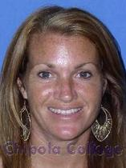

**Chipola**

Belinda Hendrix

|  |  |
| --- | --- |
| Title: | Head Softball Coach |
| Phone: | 850-718-2358 |
| Email: | [hendrixb@chipola.edu](mailto:hendrixb@chipola.edu) |

When Belinda Hendrix was introduced as the new softball coach at Chipola College, she expressed her desire to build a respectable softball program and develop her players into both scholars and players.

In ten seasons at the helm, Hendrix has certainly brought her dream into reality.  Posting an overall record of 458-134, the Lady Indians have proven themselves worthy both in the state of Florida and on the national scene.

During the 2013 campaign, Hendrix’s team won their third State Title along with FCCAA Coach of the Year award (2007, 2010, 2013).

Hendrix’s most successful season occurred in 2007 when the Lady Indians, under her direction, captured the school’s first team national title.  After posting an overall record of 57-6, Hendrix was honored by her peers by being named the 2007 NJCAA National Coach of the Year.

Coach Hendrix is a firm believer in the old cliché that hard work pays off.  She is notorious for being a student of the game and passing her passion for the sport down to her players.  She is well-known for developing players that can excel at several different positions.

Hendrix believes that the experiences and challenges her players face on the softball field will equip them with the tools to adapt and conquer anything life might throw at them.  Using this mentality, Hendrix has coached 35 All-Conference Players and 6 NJCAA All-Americans.

A 1994 graduate of Chattahoochee High School, Hendrix led her softball team to a district championship and was named Most Valuable Player.  Upon leaving high school, Hendrix received an athletic scholarship to Thomas University in Thomasville, GA, where she played on the Hawks’ softball team.

After earning her degree in Psychology from Troy University, she returned to the Florida panhandle.  In 2001, Hendrix began her coaching career at Vernon High School where she would amass a three-year record of 56-22 and two district titles.

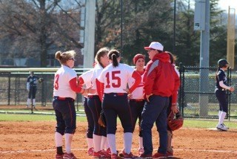

**Brewton Parker**

Randy Crawford

912-583-3177

Rcrawford@bpc.edu

Randy Crawford is set to become the next softball coach at Brewton-Parker College.  
Crawford, who has spent the past four years as the softball coach at Tennessee Temple University, will be tasked with taking a program through an extremely difficult southern states conference.  
Crawford posted a total of 50 wins in 3 competitive seasons with Tennessee Temple University as he started the program, including a NCCAA regional 2nd place finish in 2013. Crawford also carries over 27 years of experience coaching high school softball at Ooltewah High School with Coach Norma Nelson, at East Ridge High School with Coach Sandy Mouser, and at Ooltewah Middle School. He also has previously coached with select softball teams, such as the Chattanooga Austin Eagles, the Chattanooga Force, and the Tennessee Rampage.  Coach Crawford carries a big presence in south east Tennessee for softball as well as north Georgia. Before the collapse of Tennessee Temple's softball program due to the universities merger with Piedmont International University in Raleigh, NC, Crawford had totaled 7 recruits from the state of Georgia.  
Crawford says, "I am excited about working with the girls that are here and the girls we bring in. I am looking forward to building upon the program in place here at Brewton-Parker. I hope to have an effect on all the girls' growth in their relationship with the Lord."  
  
New BPC Athletic Director Daniel Prevett says about Crawford, "We believe Randy is exactly what our department needs. He brings veteran leadership and a true heart for the student athletes he works with." Prevett, who worked with Crawford at Tennessee Temple, says, "I saw firsthand how he disciples his students as well as those he works with."  
During Crawford's tenure he produced a 4x All – American Centerfielder, an All – American 3rd baseman, and several academic All – Americans. Crawford also served as the Athletic Director at Tennessee Temple University and drew high praises from former TTU and now Brewton Parker president Dr. Steven Echols.  
Coach Crawford's testimony is the he accepted Christ as his Savior at the age of eighteen, at Sholar Avenue Baptist Church, a chapel of Highland Park Baptist Church. His favorite Bible verses are Psalm 121:1-2 "I will lift up mines eyes unto the hills, from which cometh my help. My help cometh from the Lord, which made heaven and earth". Crawford's goal is to see spiritual growth in the lives of his players and to establish a first class college fast-pitch softball program. Crawford and his wife Lori live in East Ridge and have three daughters, Lora Snyder of Pheonix, Arizona, Kelli Kilgore of Houston, Texas, and Ami Crawford a teacher at Grace Academy in Chattanooga, TN.  
Coach Crawford is a graduate of East Ridge High School, he received his B.S. degree in Secondary Education from the University of Tennessee at Chattanooga, and a M.Ed from Tusculum College.

Also Attending

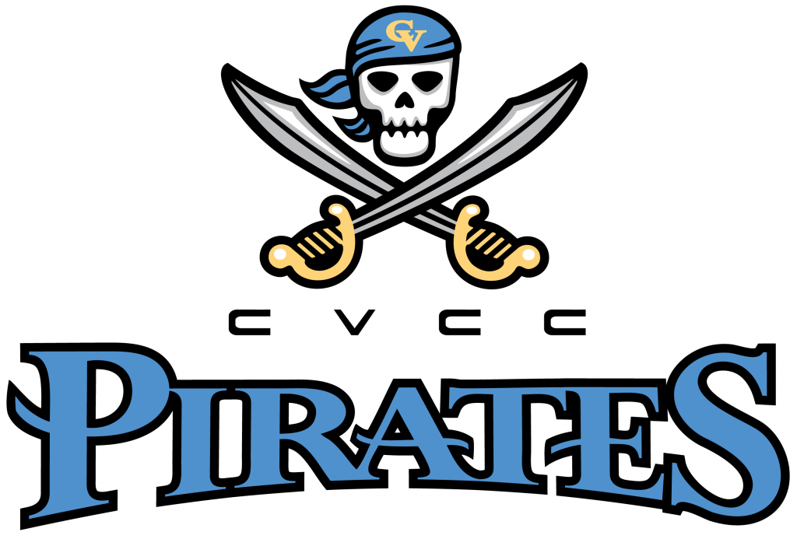

**Alma Mater:**

[**mminick@ccga.edu**](mailto:mminick@ccga.edu)

**912-279-5940**

